SOAP NOTE Monoarticular Pain and Gouty Arthritis
Jomel D. Hernandez Nieves
University Ana G. Mendez
NURS 504: Advanced History Taking and Physical Assessment
Professor: Carlos Rios Santana
June 7, 2021

PATIENT INFORMATION
NAME: John Smith
AGE: 42 years
SEX: Male
CC: Pain right foot
SUBJECTIVE:
HIPI: This is a 42-year old male who presents to the clinic after feeling pain in his right toe. He was unable to move by himself, he is barefooted. The intense pain began in the night, while during the day he was busy carrying activities in his farm. According to John, he does not recall if he did anything that injured his toe. His farm boots were on while he was at the farm. The previously night he was complaining of pain that made him not to fall asleep. The pain that he was feeling is described as a sharp pain which was stabbing. Even after taking some pain relivers the pain was still intense. He still feels the same pain at the moment. He does not experience any form of symptoms pain he was complaining of. He does not feel pain in the fingers, wrists, elbows, knees, or ankle. He has been experiencing lingering discomfort previously.
ALLERGIES: Penicillin and Milk
CURRENT MEDICATIONS:
There is no current medication that the patient was on. Patient stated that he took Tylenol 500mg 2 tabs at bedtime due to pain rt foot.
PMHX: None
FAMH: Patient stated that he doesn’t know his family medical history.
SOCHX: Patient accepts he has been using alcoholic beverage. He denies use of the drugs illegal.
REVIEW OF SYSTEMS:
HEENT
Constitutional symptoms such as intense pain, limited range of motion, inflammation, redness and lingering discomfort. The patient denies headache, dizziness, and lightheadedness. The patient says he can see clearly without glasses and can differentiate similar things. Concerning his ears, he denies hearing loss or pain from the ears. He also denies sore throat and nasal congestion.
NECK: patient denies pain in the neck, goiter pain, or swollen glands.
HEAD: Traumatic, normocephalic, with no visible recessions, scarring or palpable masses.
EYES: There were no symptoms of infection on the lid and the conjunctiva. After conducting the exam for the pupil, it revealed that the pupil was reactive with no defect associated with papillary. Optic discs had normal color, and were cupped bilaterally. Retinas were flat with normal vasculature in an out position. No peripheral holes were observed
EARS: Eustachian tube had no abnormalities. Cochlea, vestibules and semicircular tubes were intact. No uric acid crystal on the surface of the ear
NOSE: The nasal bones had no abnormalities; nasal septum was intact and nasal cartilage were in normal condition
THROAT: Throat exam revealed the hypopharynx were, there was no sore in the throat, no reddish color on the skin around the throat
RESPIRATORY: The evaluation of respiratory test revealed that respirations were occurring without use of muscles accessory. There were no intercostals rectifications. No chest resonance after conducting chest percussion. There was normal tactile fremitus
CARDIOVASCULAR: Peripheral vascular system exam revealed varicosities absent, full to palpation, no edema, and extremities warm to touch, and no abnormalities were noted. No thrill was noticed on the heart palpation which is found on the fifth intercostals in midclavicular line.
GASTROINTESTINAL: The GI test revealed no abnormalities on the stomach and the esophagus. The small intestine had no abnormalities
GENITOURINARY: After conducting vaginal vault exam, the result showed no abnormalities.
MUSCULOSKELETAL: The station exam showed malposition had no abnormalities.
NEUROLOGIC: Examination of cranial nerves showed no deficits; Deep tendon reflexes were normal. Vibratory, pin proprioception sensations and touch are normal. The insight for the patient is well as well as his judgment.
OBJECTIVE
Vital Signs:
Time: 11:00am Temp: 98.4 B/P: 126/81mmhg P: 71 bpm R: 18p/min
Sat: 97% R/A Weight: 175 lbs. Height: 5’11”
CONSTITUTIONAL: The joints which were affected were warmer as compared with the other part in which the patient was not complaining of the pain. The toe was swollen; this could be noticed even before the patient started explaining. The joints which were affected were tender. There was redness on the joints which were affected by the diseases. The patient was unable to move his joints normally; the joints were able to move after he excited certain pressure on them.
The blood test was carried out to determine the level of uric acid in the blood. Since the level of uric acid varies among different individuals, it cannot be used to determine if someone has gout or not. A joint fluid test was conducted where the fluid was withdrawn from the affected joint of the patient by the use of the needle to examine the presence of the urate crystal on the microscope. Additionally, the ultrasound was carried out to detect the availability of urate crystals in the joints.
To certain more, if the pain is having a result of gout; x-ray imaging was conducted on the affected joint to determine the real cause of the inflammation that was resulting in the pain. Different x-ray images which were captured from a different angle of the affected joints were combined to observe the presence of urate crystal in the joints.
Skin: On the toe there was formation tophi this resulted due more accumulation of the urate crystal in the body.
Head: Head is normocephalic, atraumatic and without lesions; hair evenly distributed according his race and age.
Eyes: EOM and lids are normal. Pupils are equal, round, and reactive to light. No scleral icterus. Vision 20/20 verified by Snellen Chart, perimetry and campimetry are apparently normal.
Ear: Auricle well-formed, no drainage from external conduct noted. Otoscopy: Bilateral conducts clear with intact tympanic membranes. No sign of infection.
Nose: Moist nasal mucosa. The nasal septum is midline. However, flaring is noticed. Septal deviation and discharge. Lesions and bruises in the nose can be seen. Inflammation also presents.
Neck: Full ROM; no cervical lymphadenopathy; no occipital nodes. No thyromegaly or nodules.
Mouth: Buccal nodules and lesions present. Tonsillar swelling or exudates in the pharynx. Adenopathy noted.
Teeth: normal dentition according to his age, no cavity at a glance.
Pharynx: is non-erythematous and without exudate, normal tonsils, symmetric and centered uvula, nauseous reflexes present.
Respiratory: The evaluation of respiratory test revealed that respirations were occurring without use of muscles accessory. There were no intercostals rectifications. No chest resonance after conducting chest percussion. There was normal tactile fremitus
Cardiovascular: No thrill was noticed on the heart palpation which is found on the fifth intercostals in midclavicular line.
Peripheral vascular: No cyanosis, peripheral pulses present and normal. Capillary refill <3 seconds. No edema.
Gastrointestinal: No abdominal pain, nausea, diarrhea, or vomiting. The patient is negative for tenderness or distention observed upon palpation. Bowel sounds in all four quadrants. No bloating or excess gas.
Genitouinary: No bladder distention, CVA pains, or suprapubic pain.
Hemo/Lymphoietic: no adenopathy noted, no bruises or bleeding, colored mucous membranes Spleen no visible, palpable or percussive
Musculoskeletal: no tenderness to palpation, normal joint stability in all extremities. No deformities or curvature. Strong muscles, able to maintain flexion against resistance and without.
Neurologic: patient oriented in time, place and person, responds with clear and precise language. Sensitive to light touch. Gait within normal limits. Coherent thoughts.
ASSESSMENT:
DIAGNOSIS:
Gout: The patient had swollen toe, which was warmer as compared to the other parts of the body. It was reddish as well as tender. After carrying out the test, the urate crystals were observed in the joints that the patient was complaining of pain. Around the elbow, and the back of the finger’s tophi was seen. On the fingers on which the tophi were observed, gritty white material with pus-like fluid was flowing. On the x-ray images, the bone and the cartilage around the affected area were damaged by the growth of the tophi

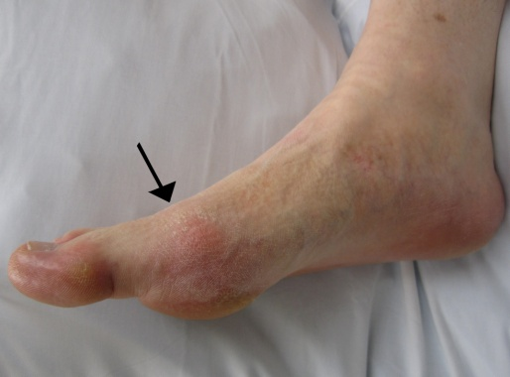
The toe infected with gout.
DIFFERENTIAL DIAGNOSIS:
The differential diagnosis is administered after the symptoms of the infection was determined such redness of the skin. The diagnosis was done after the patient condition could not improve. To help with diagnosis, the synovial fluid gram staining was performed as well as the culture. The tophi were located in the patient joint.
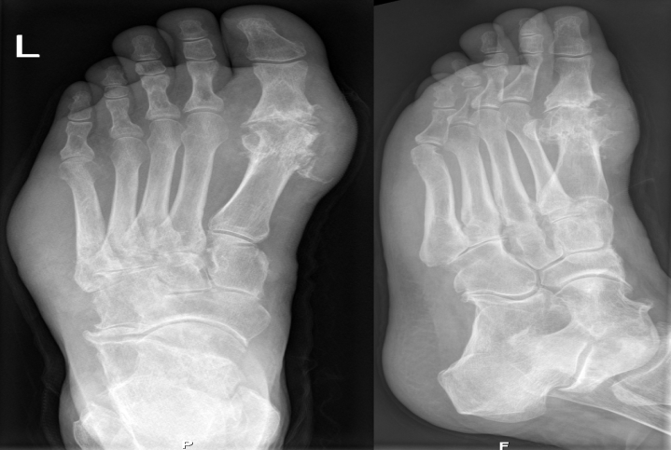
X ray image of foot suffering from gout
PLAN:
The gout was treated by using two methods. One method was to decrease the pain which is associated with inflammation when someone is attacked by gout. The other method was administered to lower the amount of uric acid in the body of the patient thus minimizing the complications which are associated with the disease.
Non-Pharmacologic treatment:
The patient was also encouraged to do regular exercise while at home this will ensure that his body remains healthy and having a good weight thus reducing the risk of suffering from gout. To avoid food that contains a high number of purines such as red meat, sardines, scallop, and mussels. Additionally, the patient was encouraged to be taking more water and avoids alcoholic beverages as well as drinks that as sweetened with fructose.
Pharmacologic treatment:
MEDICATIONS:
- Ibuprofen 200mg 4 tabs PO every 6 hours
- Protonix 40mg 1-tab PO daily
- Colchicine 6mg (10 tablets) starting dose 1.2mg (two 0.6mg tablets), followed by 1 tablet every 2 hours. Maximum dose of 6mg (10 tablets)
- Probenecid 250mg (one-half of a 500mg tablet) two times a day for 7 days, then 500mg 1 tablet two times a day for 21 days
- Cortisone 100mg injected to the muscle
The patient has been treated with nonsteroidal anti-inflammatory drugs (NSAIDs) which will help to reduce inflammation and the pain which is associated with gout. The NSAIDs which the patient was stat is, ibuprofen. Since the NSAIDs are usually prescribed for a long period, a proton pump inhibitor was also administered to prevent the patient from digestive system problems.
Colchicine was also used for the treatment of gout. It is usually effective when it comes to inflammation reduction which is caused due to accumulation of the urate crystal. The patient was instructed on how to take the medicine, incases the symptoms starts. Corticosteroid drugs were also administered which can control pain and inflammation. Corticosteroids were injected into the patient's joint; however, the patient was informed about the side effects which are associated with this medication.
The patient was also advised on how to prevent the complications which are associated with the disease through taking medication that will ensure the production of uric acid is blocked. A drug such as a login limits the ability of the body to make uric acid. Furthermore, the patient was advised how he can improve the removal of uric acid from the body by taking medication such as probalan (Probenecid).
FOLLOW-UPS/REFERRALS:
The follow up was schedule after 2 weeks of treatment. In case of similar pain in different body part the patient should notify the doctor immediately.
Side Effects Explained: Yes _x__ No ___ Continue same medication: ___
Patient Education: Verbal __x_ Written __ Health Education: Yes _x__ No ___
Nutrition: Regular Diet _x_ Diabetic Diet __ Calories __ Low Fat __ Low Salt __
Ulcer Diet __
Next appointment: In 2 weeks.
RATIONALE:
When the drug is started in acute gout, the quicker the response is. Poor patient compliance result to the failure of the treatment. Prophylactic treatment should not be administered during or after the episode of gout. The dose of allopurinol to remain unchanged during an acute episode of gout.

